**3. ReactJS-HOL**

**Output**

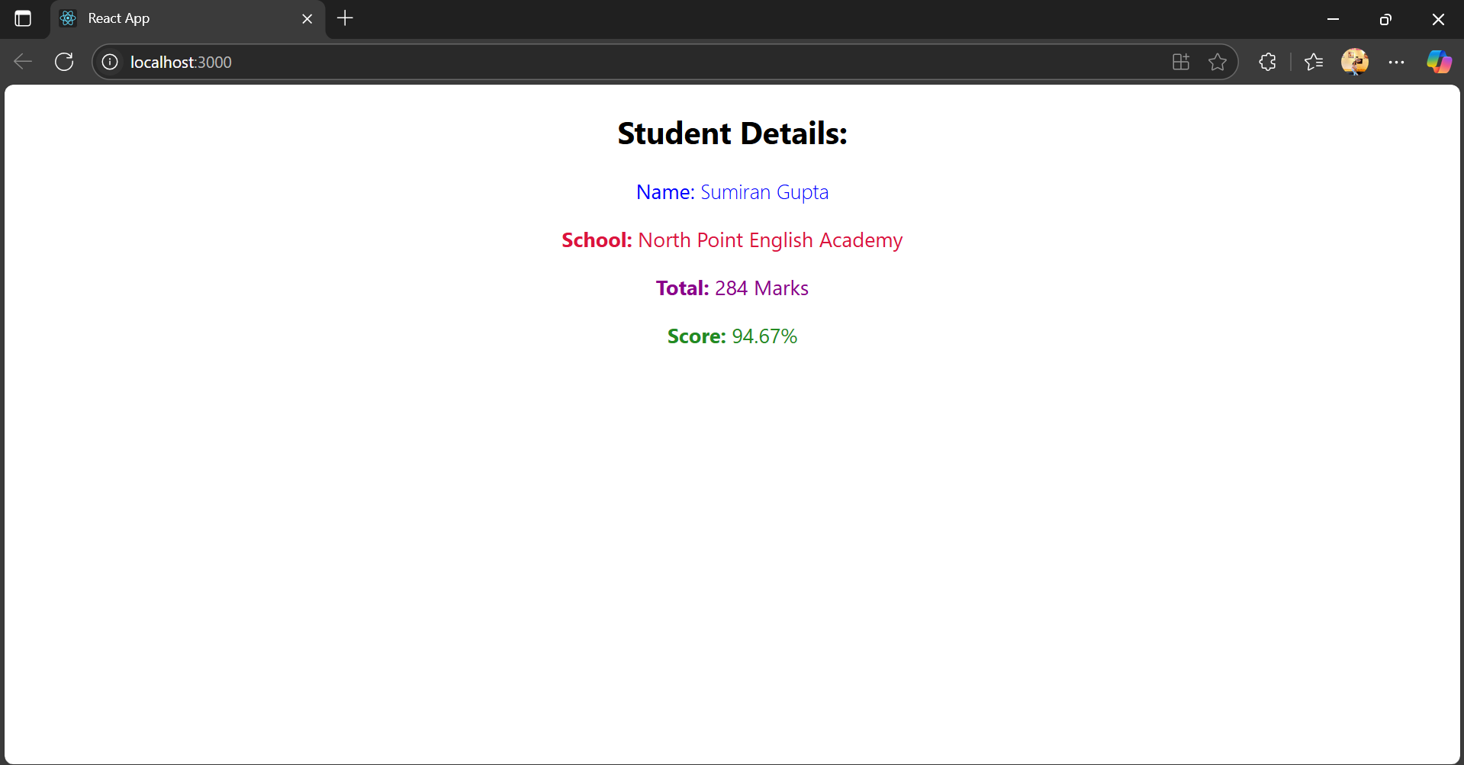

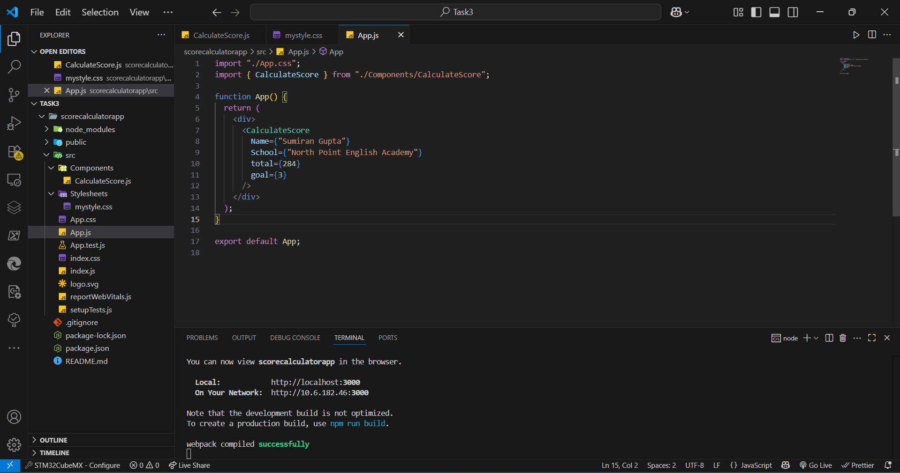

**App.js**

import "./App.css";

import { CalculateScore } from "./Components/CalculateScore";

function App() {

return (

<div>

<CalculateScore

Name={"Sumiran Gupta"}

School={"North Point English Academy"}

total={284}

goal={3}

/>

</div>

);

}

export default App;

**Components/CalculateScore.js**

import "../Stylesheets/mystyle.css";

const percentToDecimal = (decimal) => {

return decimal.toFixed(2) + "%";

};

const calcScore = (total, goal) => {

return percentToDecimal(total / goal);

};

export const CalculateScore = (props) => {

return (

<div className="formatstyle">

<h2>Student Details:</h2>

<p className="Name">

<b>Name:</b> {props.Name}

</p>

<p className="School">

<b>School:</b> {props.School}

</p>

<p className="Total">

<b>Total:</b> {props.total} Marks

</p>

<p className="Score">

<b>Score:</b> {calcScore(props.total, props.goal)}

</p>

</div>

);

};

**Stylesheets/mystyle.css**

.Name {

font-weight: 300;

color: blue;

}

.School {

color: crimson;

}

.Total {

color: darkmagenta;

}

.formatstyle {

text-align: center;

font-size: large;

}

.Score {

color: forestgreen;

}